 | 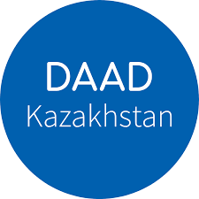 | 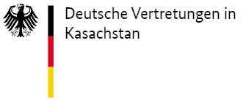

Х Kazakh-German Logistics Forum

December 7-9, 2022

7 December | Workshops
8 December | Logistics Forum
9 December | Case-competition for students and Vacancies Fair from Companies

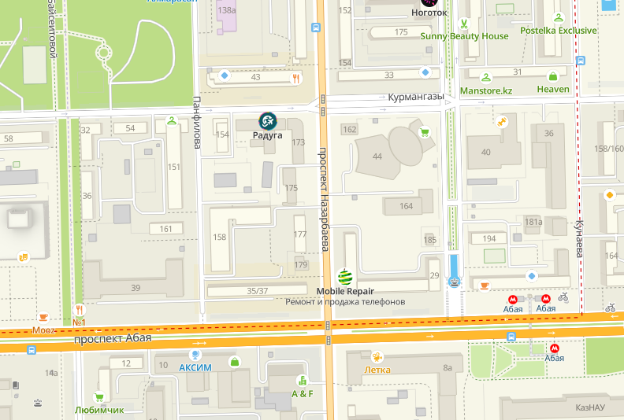
Kazakh-German University,
Nazarbayev Ave., 173, Almaty

To register, follow this link:

https://forms.gle/DEMx2Bb6tMe6q2Hh6

Х Kazakh-German Logistics Forum
Workshops
7 December 2022

10:00-11:00 |  | MARAT USPANOV  General Director of the freight forwarding company «Starget» | Modern issues in logistics
11:00-11:15 -Technical break
11:15-12:15 | 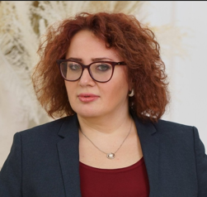 | OKSANA SOROKINA  General Director of SevenR Logistics | The problem of crossing the Kazakh-Chinese border, the ways of problem solution. The passing capacity of terminals on the border. How the problem is solved at the state level. The working process of an expert for logistics.
12:15-12:30 Coffee break
12:30-13:30 | 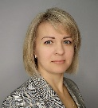 | YELENA MEZENTSEVA  General Director of LLP «Barrus Projects» | Logistics schemes for project cargo deliveries to Central Asia and the challenges of their implementation in the current environment.
13:30-14:50 Lunch break
14:50-15:50 |  | KULAGINA NATALIYA  General Director, Vestа-Kazakhstan LLC | Ways to reduce supply chain costs, ways to reduce transport costs. Difficulties in supplying to Kazakhstan due to the current world situation. What are the ways of solving this problem?
15:50-16:50 |  | JOHANNES RENTSCHLER  Scientific Fellow at the Chair of Management and Logistics  Technical University of Darmstadt | Multimodal transportation
17:00 Technical break
17:00-18:00 |  | HANS HOLZHACKER  Chief Economist of CAREC Institute | CAREC CORRIDOR  PERFORMANCE MEASUREMENT AND MONITORING  THE CORONAVIRUS DISEASE AND ITS IMPACT
18:00 Closing of the first day of the Forum

Х Kazakh-German Logistics Forum
Logistics Forum
8 December 2022

09:00-10:00 Registration
Forum opening
10:00-10:10 | 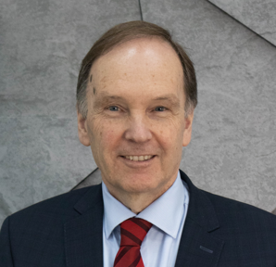 | Prof. Dr. WOLRAD ROMMEL  President of the Kazakh-German University
10:20-10:30 | 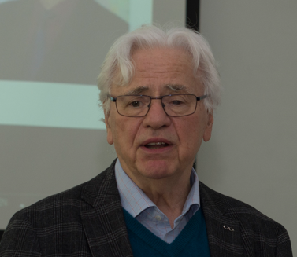 | Dietrich Thess  Founder of LogCentre
Plenary session
10:30-13:00 | 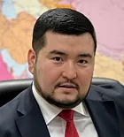 | GAIDAR ABDIKERIMOV  Secretary General of the legal entity merger «International Association «Trans-Caspian International Transport Path» | «Trans-Caspian International Transport Path (TCITP) – new opportunities and challenges»
 | 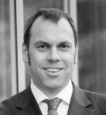 | Prof. Dr. RALF ELBERT  Head of the Chair of Management and Logistics  Technical University of Darmstadt
HANS HOLZHACKER
Chief Economist of CAREC Institute
 | 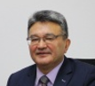 | KANAT MUKUSHEV  Deputy General Director of the legal entity merger «Union of Transport and Logistics Organizations and Associations «KAZLOGISTICS»
Dr. DINA AZHGALIYEVA
Research Fellow Asian Development Bank Institute
 | 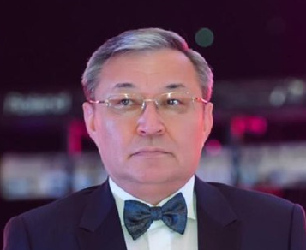 | AITMOLDIN SERIKBOL  Advisor to the Director of LLP Tau Logistics on the questions of logistics
 | 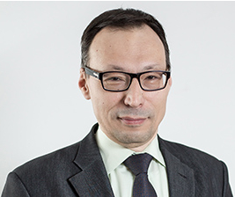 | MARAT NARIBAYEV  Professor, Doctor of Science, Corresponding Member of the Kazakh National Academy of Natural Sciences
13:00-14:30 Lunch break

SECTION “The role of science and education in the development of the transport and logistics industry”
14:30-17:00 |  | Dietrich Thess  Founder of LogCentre | «Made in Germany» - the development of educational programs on the example of Germany
 | 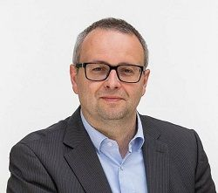 | JENS WOLLENWEBER  Supervisor of the research group «Transport logistics»;  Program Director for Logistics (Bachelor programs) and Technical Management (Master programs) TH Wildau | «Made in Germany» - the development of educational programs on the example of Germany
 | 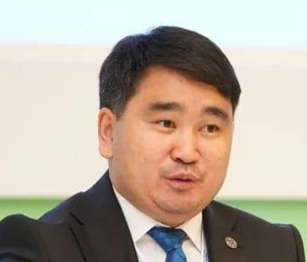 | YERBOL MUKHAYEV  Deputy General Director of CILT Kazakhstan | The role of international organizations and institutions in the development of transport and logistics industry of the region
18:00 Dinner (by invitation)

Х Kazakh-German Logistics Forum
Case-competition for students and Vacancies Fair from Companies
9 December 2022

09:00-10:00 Registration
10:00-13:00 | Case-competition for students
13:00-14:35 Lunch break
14:40-17:00 | Vacancies Fair from Companies

