Appendix I

Participant Registration Form
XIV Annual International Scientific Student Conference "Contemporary Global Trends: Challenges and Risks for Central Asia"
Almaty, DKU, April 1, 2022.

Full name | in Russian  in Kazakh  in English
Country, city
Educational institution, faculty, major, year (include both full and short name)
Phone/fax
E-mail
Conference Section (full name and number)
Supervisor (full name, academic degree and title, institution) | in Russian  in Kazakh  in English
Paper title | in Russian  in Kazakh  in English
Paper abstract
(no longer than 250-300 words)

Appendix II

PUBLICATION REQUIREMENTS

I. Article structure:
- Title (center-aligned, in capital letters) (see the template)
- Author/s info on top right corner (full first and last name, course, specialty/EP, university, E-mail, supervisor, academic title, affiliation, E-mail (see the template)
- Short abstract
- Introduction, the rationale
- Main research findings, results and arguments
- Conclusions and recommendations
- References (see the template)

Template:
RENEWABLE POWER SOURCES: GLOBAL TENDENCIES

Asan AKHMETOV

MA, «Integrated water resources management»,

1st year, Kazakh-German University (DKU),

ahmetov@dku.kz

Supervisor:

Ivanov Ivan

Doctor of Engineering, Professor

Kazakh-German University (DKU)

i.ivanov@dku.kz

Резюме/Summary/Түйін/
(depending on paper language)
II. Formatting Requirements:
- Size – no longer than 10 pages
- Font Times New Roman, size – 14
- Line space – single; margins: upper and lower - 2 см, left – 3 см, right – 1,5 см
- Titles are center-aligned, epigraphs – flush right, paper text – full justification, indented, if necessary
- Bold is used only for title, author name; italics is used for digressions from main contents, some examples and footnotes; quotes are marked «…».
- References are provided throughout text in square brackets with Arabic numerals, e.g. [1].

Template:
REFERENCES
1. Vertrag über die Gründung der Europäischen Gemeinschaft für Kohle und Stahl vom 18. April 1951 // Quelle: BGB1. – 1952 II – S.448-475.

2. «Зеленая» экономика: глобальный тренд развития [Electronic resource] / Available at: http://www.kazenergy.com/ru/2012-06-20-08-42-46/2012-06-20-13-01-53/9027-l-r-.html (23 September, 2013)
The use of illustrative materials is allowed in the work. Illustrative materials are presented in the following formats: for photos, drawings — tiff or jpeg (300 dpi); graphs, diagrams and are located in the text of the article. The name of the drawing is formatted in the center. If necessary, illustrations can be supplemented with explanatory data in the form of a pictorial text.
Example of drawing design:
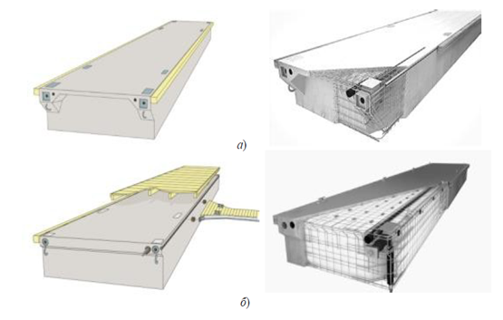
Figure 1. General view and main design elements of mooring pontoons: a-type 1 (M3320BRS); b-type 2 (M3315HDS) and type 3 (M2715HDS)
Tables should be prepared using standard MS Office tools. The table label is formatted by width.
Example of a table:
Table # 1. Technical specification of mooring pontoons based on research findings
 | Type of mooring pontoons
 | Type 1 (M3320BRS) | Type 2 (M3315HDS) | Type 3 (M2715HDS)
Design waterline length L wl, m | 19.32 | 14.68 | 14.68
Length overall Loa, m | 19.90 | 14.92 | 14.92
Design waterline breadth Bwl, m | 3.00 | 3.00 | 2.40
Breadth overall Boa, m | 3.30 | 3.30 | 2.70
Hull height H, m | 1.00 | 0.85 | 0.85
Free board loaded h gr, m | 0.25 | 0.27 | 0.27

All formulas must be typed using the built-in equation editor. Formulas are placed in the center of the text; their sequence number is indicated in parentheses and placed in a line with the text aligned to the right. For references to formulas in the text, parentheses are used. Formulas are typed in the same font as the main text. It is not allowed to save formulas in the form of a figure, and place them in a table!
Example of formulas:
, (1)
Where H₁ — scale hull height, m, counted according to formula
(2)
Where H — hull height, m
— length and height of i-line superstructure

III. Responsibility.
The author is responsible for the content of the article, the editorial board reserves the right to publish or reject the manuscript, as well as the right of editorial revision. Articles are accepted for publication with a proof of originality of not less than 70.0% in the system strikeplagiarism.com.

